* Student Name – Yash Sinojia
* Student ID – A00268852
* Course – Master of Science in Data Analytics (Full-time)
* Date – 16th Oct 2019
* Title of Assignment – Role of Data Analytics in an Organization
* **Introduction**

Today more than 2.5 quintillion bytes of data are produced every single day and by 2020 it’s estimated that 1.7 MB of data would be produced per second for every person on earth. Which is an enormous lot of data. And hence, we need Data Analytics. With great data, comes great power, and even greater responsibilities.

* **General Roles and Responsibilities**

Based upon domain expertise and enterprise goals, following are the roles and responsibilities that every Data Analyst based organizations have as per the order:

1. Understanding the whole business picture

As a means of coordination between technical teams and management teams.

1. Data Collection and Data Mining

To shortlist the right amount of data from various external sources by recognizing the patterns and correlations that it can provide.

1. Data Cleaning

The process of thoroughly cleansing the raw data and structuring it by getting rid of all the anomalies.

1. Data Analysis

The most central role. Using computational method, logical and statistical reasoning, the structured data is explored and evaluated by Data Analytics tools.

1. Gathering Insights

In this stage, the answers to the question are sought by coming up with correlation and patterns and trends to understand the current model and come up with a more efficient model for the future.

1. Presenting Valuable Insights

Reporting the essential information from data with various spectacular visualizations.

1. Database Maintenance

To store the obtained data in modular database systems and to maintain it (Kurt, 2019).

* **Part I: Organizational Structures**

The structure of a data analytics-oriented organization defines its major functionality. It has an impact on data flow, resource sharing, collaboration, nexus, and protocols of the organization. There are several options when it comes to implementation:

**Analytics Governance**

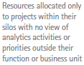

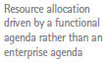

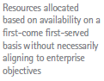

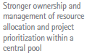

**Project Management**









**Location**



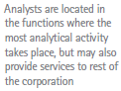

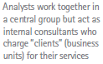

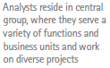

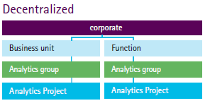

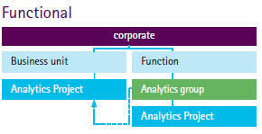

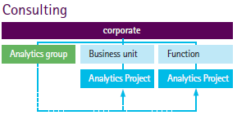

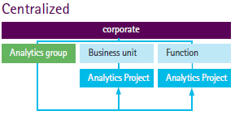

*Figure 1: Options for Implementing Analytics Organization* (Hernandez, n.d.)

These are the general organization structure followed by most of the analytical organization, depending on their functionalities. However, a recent McKinsey Analytics survey analyzed that only 8% of 1000 organizations with analytical domains truly engaged in effective scaling practices. Because over-centralization causes blockades and leads to ineffective accession and decentralization make hurdles in data flow and decision making. In the functional model, the enterprise agenda gets clouded and the resource allocation is unprioritized and thus compromised. Thus, the need for a more effective hybrid model arises.

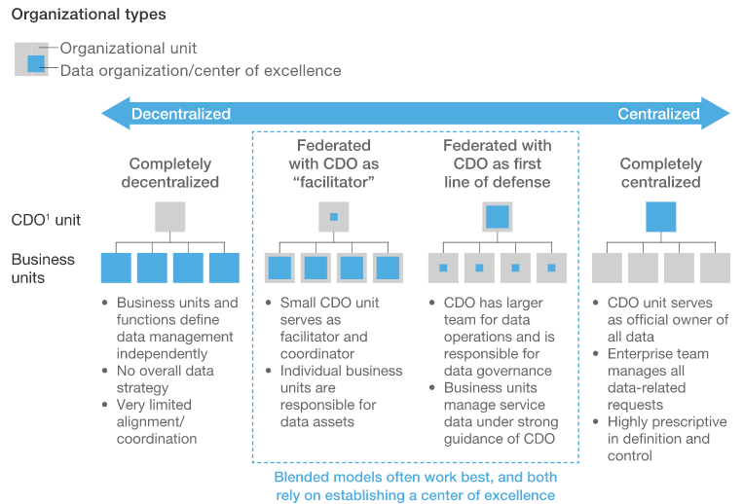

*Figure 2: Hybrid organizational models for broadscale analytics initiatives* (Fleming, 2018)*.*

In such hybrid models, the agile teams are a concatenation of talented experts from both the analytical domain and the business domain. It even retains some centralized capabilities and decision rights and although the analytical expertise is included in the business with responsibilities for outcomes.

For a bunch of organization, the extent of centralization may change with time. In the initial stages, centrality seems easier to develop and ensure the consistency of outputs from other dependents. But when the business reaches some leviathan stages, it is better to assign more independence among the roles (Fleming, 2018).

* **Center of Excellence Model**

This model is centralized by a team called CoEs which include people from both analytics and business domain as discussed above. These CoEs (a focal point for knowledge management) are responsible for methodology, adoption of tools, training, decisions and coordination among dependent units within some focused areas and a strict pre-determined goal.

**Project Management**



**Location**

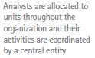

**Analytics Governance**

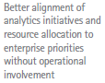

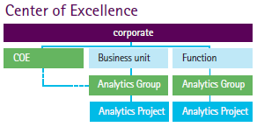

*Figure 3 Center of Excellence Model* (Hernandez, n.d.)

* **Advantages of CoEs**
  + - * 1. Effective utilization of resources
        2. Better products and efficient quality of services to customers
        3. Eradicates ineffective modes and reduces the cost of products or decisions
        4. Saves time to implement new skills and technologies
        5. Effective governance and consistency

(Anastasia, 2016)

* **Steps to consider while forming a CoE**
  + - 1. Identify the experts for the team and the scope of it.
      2. Schedule meetings and frequency of meetings to share developments within CoE to everyone else.
      3. Set metrics for organizational targets which are checked consistently and improved.
      4. Organize a resource hub for everyone to share tools, updated protocols and updates on CoE activities.

(Hou, n.d.)

* **Case Study: Evolving the CoE at a Large Australian Bank**

In the early phase, the company adopted analytics pods to facilitate analytics in business. But a loose reporting structure led to excessive hiring, inefficiency in resource sharing and uneven distribution of the entire business picture. Then the bank switched to introduce an offshore Analytics CoE which will help them adjust their analytical services on the basis of business demands. The evolution of such structure happened in three phases under the time frame of two and a half years.

* + - 1. In the first year, the bank formed a centralized Analytical structure to come up with all the analytical solutions.
      2. In the second phase, the new CoE provided solid trainings to the Analytics experts on the business perspective for six months so that they could understand the industry trend and optimize solutions to customers.
      3. The last phase was focused on training the business domain to efficiently utilize these insights for daily business activities and to reinforce the cruciality of Analytics in the entire organization.
* **Part II: Data Analytics in Sports**

With an exponentially growing fanbase, sports organizations have been always looking for new epochs on their winnings on the pitch and the corresponding business advances outside it. They are using statistics with data analytics tools to come up with better decisions. But researchers say that sports analytics is just in coming-of-age, there’s plenty of room for development. It is estimated a leviathan 40.1% CAGR next decade, reaching a potential value of USD 3.97 billion in 2022 (Athithya, 2019).

* **The Moneyball**

It all started with the “Moneyball phenomenon”, to the extent that the term Moneyball is referred to a shorthand term for the use of data in sport. The term was first used in the Michael Lewis’ book about Billy Beane, who was the general manager of the baseball team: Oakland Athletics from 1998 to 2016. He hired Peter Brand, an economics graduate from Yale. Rather than emphasizing on experiences and intuitions, Brand used on-base percentages to hire players. It proved to be a significant success within a very low budget.

The traditional methods of finding value in football were biased upon players who have peaked at an international tournament. However, the trends of long-term performances and the tendency to overweigh their own experiences were largely overlooked. After Moneyball, the numbers told a story that the eye missed. Even today, the key is finding the undervalued statistic that correlates to winning before anyone else does (Lewis, 2018).

* **Sport Analytics in Business**

Nowadays real-time videos, wearable devices and tagged equipment are used to track key analytic points like tracking the locus of players and movements of the ball, which may help train players more effectively. Analytical organizations can even detect patterns in the digital engagement of the viewers. The New England Patriots gather data on what audience buy at the shop and when they buy tickets, with this data they do predictive analytics for future ticket prices and staffing on game day. Data also facilitate sports businesses revolving around sponsorship, advertising and player trading. Teams can optimize these recruitments and save a lot of funds (Ricky, 2019).

Besides, clustering algorithms can be run of fan bases to run campaigns on targeted clusters. Also, sports analytics can have a huge impact on legalized gambling which covers 13% of the global gambling market (Athithya, 2019).

# **References**

Anastasia, 2016. *How to Set Up a Center of Excellence.* [Online]   
Available at: https://www.cleverism.com/how-set-up-center-excellence/  
[Accessed 11 Oct 2018].

Athithya, V., 2019. *Scope of Data Analytics in Sports World.* [Online]   
Available at: https://towardsdatascience.com/scope-of-analytics-in-sports-world-37ed09c39860  
[Accessed 09 Oct 2019].

Fleming, O., Fountaine, T., Henke, N., Saleh, T., 2018. *Ten red flags signaling your analytics program will fail.* [Online] Available at: https://www.mckinsey.com/business-functions/mckinsey-analytics/our-insights/ten-red-flags-signaling-your-analytics-program-will-fail  
[Accessed 07 Oct 2019].

Hernandez, J., Berkey, B., Bhattacharya, R., n.d. *Organizing, Governing, Sourcing and Growing Analytics Capabilities in CPG.* [Online] Available at: https://www.accenture.com/us-en/~/media/accenture/conversion-assets/dotcom/documents/global/pdf/industries_2/accenture-building-analytics-driven-organization.pdf  
[Accessed 12 Oct 2019].

Hou, Z., n.d. *What is a Center of Excellence and Why Do You Need One?.* [Online]   
Available at: https://www.convinceandconvert.com/social-media-strategy/what-is-a-center-of-excellence/  
[Accessed 11 Oct 2019].

Kurt, 2019. *Data Analyst Roles and Responsibilities: All You Need to Know.* [Online]   
Available at: https://www.edureka.co/blog/data-analyst-roles-and-responsibilities/  
[Accessed 10 Oct 2019].

Lewis, M., 2018. *Moneyball: The Art of Winning An Unfair Game.* [Online]   
Available at: https://www.tifofootball.com/features/moneyball-the-art-of-winning-an-unfair-game/  
[Accessed 08 Oct 2019].

Ricky, A., 2019. *How Data Analysis In Sports.* [Online]   
Available at: https://www.forbes.com/sites/forbestechcouncil/2019/01/31/how-data-analysis-in-sports-is-changing-the-game/  
[Accessed 13 Oct 2019].